Design Brief/Document on the Availability of Computers at the New School
- Problem Statement
The computer labs at the New School do not have a systematic method of finding available computers.

- Problem Description
There is currently one location that displays the computers that are available at the New School labs. However, there are seven computer lab locations and few students are aware of the “Computer Availability” screen located on the main floor of 55 West 13th Street. Additionally, there are only 310 computers for 9,825 enrolled New School students to use, creating an overflow of students waiting for opening computer stations daily.

- Evidence/Research
The first method of research was to monitor the “Computer Availability” screen located on the main floor of 55 West 13th Street. Three days of observation were made to monitor the patterns of students and the use of computers in different locations at different times.
The second method of to speak to the lab manager on the 3rd floor of 55 West 13th Street, Emre Balik. He said the “Computer Availability” monitor is online as well, but only accessed by staff members. Also that 8th floor audio/video editing computers can be reserved online. He suggested to go to the Academic Technology office on the 7th floor. The 7th floor office told me to send e-mail to at@newschool.edu.
Therefore, the third method of research was to send an e-mail to New School’s Academic Technology with a series of questions, as attached. I had e-mailed twice but there was no response.

- Results
Based on the three methods of research, it was observed that New School students mainly used the computers on the 3rd and 8th floors of 55 West 13th Street. Also, students densely used the New School computers during noon-times on weekdays. Additionally, most students who entered the 55 West 13th Street to access the computer labs did not view the “Computer Availability” monitor. This caused students to wander around computer labs during peak-hours.

- Conclusions/Recommendations
The “Computer Availability” is a helpful source that many New School students are unaware of. Therefore, making this information accessible in more locations would increase the efficiency for students in finding open computer spaces. Moreover, creating a system that guarantees students a computer station by building a touch-screen on the main floor of each computer lab building to reserve stations for a timed-period will facilitate the process for students in search for a computer station.
Hello,
My name is Shin Han and I am a MFA Design and Technology student at Parsons the New School for Design. I am currently taking a Polshek Collaboration class, designing systems that enable, support, and extend institutional memory. As part of an assignment, I am researching the New School computer labs, specifically how efficient the current system/method of monitoring and delivering the availability of computers are to students. I would like to help improve the New School community and would gladly appreciate it if you could give me more insight into:
- How the availability of computers on the first floor LCD screen is operated.
- Why this information is not available on the New School website.
- If there has been any investigation as to operate a more systematic way of finding available computers during finals.
(For instance, have everyone reserve a computer space through a screen that shows visually available spots and prints out a timed-spot-- that would be installed in the main floor of Arnold Hall. Many institutions in Korea have this system as shown.)
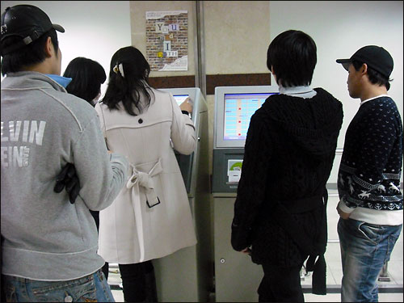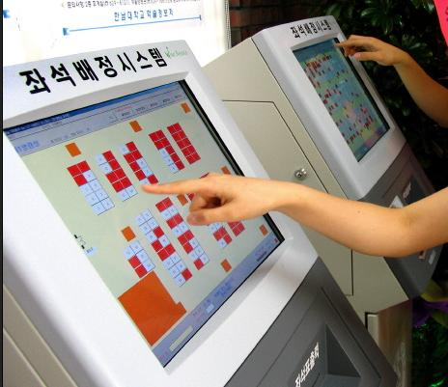
- If some of the equipment compatible computers (Arnhold Hall, 8th Fl.) can be reserved.
Thank you for your time.

Sincerely,
Shin Han

M.F.A. Design and Technology, Parsons the New School for Design |
B.S. Biomedical Engineering, Vanderbilt University

